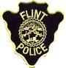
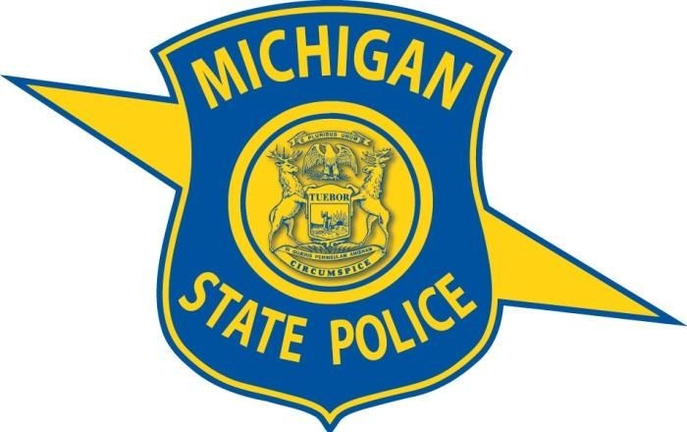

Flint Police Department and Michigan State Police
Major Case Unit

Criminal Investigations Bureau 810 237-6900 * Patrol Desk 810 237-6800 * CIB Fax 810 237-6969

Incident: Multi-Casualty Shooting

Victims: Deceased: Deceased: Alyssa McMahon W/F 09/09/02
Deceased: Alvin Hollinger II M 02/21/02
Critical: 17 year old male
Critical: 20 year old male
Serious: 18 year old female
Serious: 18 year old male

Occurred: Monday 08/09/21 at approximately 12:40 AM

Location: Broome Park (Hammerberg Rd access)

Injury/ Medical Condition: Two victims deceased, two victims in critical condition and two victims in serious condition.

Weapon: Unknown firearm

SYNOPSIS OF INCIDENT:
Flint Police Officers responded to Broome Park for a shooting incident. Officers located six gunshot victims in a parking lot at the park. Officers learned the individuals were having a social gathering in the parking lot of the park at the time of the shooting. Preliminary investigation revealed the shooter shot into a group of people. Several persons of interest are in police custody while the investigation continues into the day.

Contact Information: OIC is D/Sgt. V. Lambaria (810) 237-6971 or to remain anonymous contact Crime Stoppers at 1-800-422-JAIL (5245), P3Tips mobile app, or CrimeStoppersofFlint.com.

